**Name:** B. Nageswar

**Reg-No**: 192372005

2. Identify the system calls to copy the content of one file to another and illustrate the same using a C program.

**Aim**

To understand file handling using system calls in C by copying the content of one file to another.

**Algorithm**

1. Open the source file in read-only mode using the open() system call.
2. Open (or create) the destination file in write mode using open().
3. Use a loop to read the content of the source file in chunks using the read() system call.
4. Write the read content into the destination file using the write() system call.
5. Continue until the end of the source file is reached.
6. Close both files using the close() system call.

**Procedure**

1. Use open() to handle file descriptors for the source and destination files.
2. Check for errors (e.g., if the files cannot be opened).
3. Use a buffer to read data from the source file and write it to the destination file.
4. Handle edge cases like empty files or read/write errors.
5. Ensure both files are properly closed at the end of the operation.

**Code:**

#include <fcntl.h>

#include <unistd.h>

#include <stdio.h>

#include <stdlib.h>

#define BUFFER_SIZE 1024

int main(int argc, char *argv[]) {

int source, destination;

char buffer[BUFFER_SIZE];

ssize_t bytesRead, bytesWritten;

if (argc != 3) {

write(STDERR_FILENO, "Usage: ./copyfile <source> <destination>\n", 41);

exit(1);

}

source = open(argv[1], O_RDONLY);

if (source < 0) {

perror("Error opening source file");

exit(1);

}

destination = open(argv[2], O_WRONLY | O_CREAT | O_TRUNC, 0644);

if (destination < 0) {

perror("Error opening destination file");

close(source);

exit(1);

}

while ((bytesRead = read(source, buffer, BUFFER_SIZE)) > 0) {

bytesWritten = write(destination, buffer, bytesRead);

if (bytesWritten != bytesRead) {

perror("Error writing to destination file");

close(source);

close(destination);

exit(1);

}

}

if (bytesRead < 0)

perror("Error reading source file");

close(source);

close(destination);

return 0;

}

### ****Result****

The program successfully copies the content of the source file into the destination file using system calls, demonstrating efficient file handling in C.

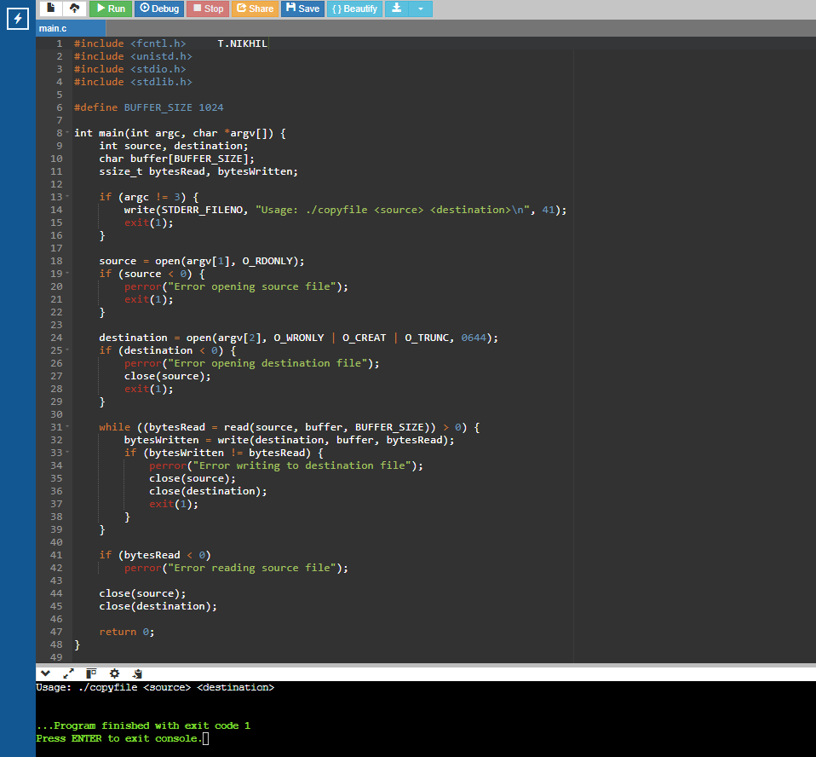**Output:**